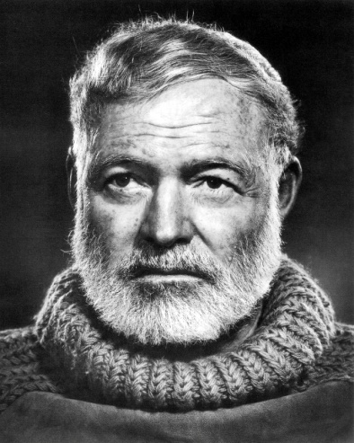 Ernest Miller Hemingway was born in Oak Park, Illinois, in 1899, the son of a doctor and a music teacher. Hemingway wrote for the school paper at his high school, and disappointed his parents by eschewing college to go to work immediately after graduation. His first job was as a cub reporter for the Kansas City Star, a position arranged by an uncle who had a friend in the newspaper's editorial department. Though Hemingway only remained with the Star for a short time, he wrote about "fires, fights and funerals, and anything else not important enough for the other more experienced reporters", and took the paper's writing rules to heart — short sentences, short paragraphs, and a straightforward, forceful writing style. "Those were the best rules I ever learned for the business of writing," he later wrote. "I've never forgotten them."
When America entered World War I in 1917, Hemingway tried to enlist in the US Army, but was rejected for his poor eyesight. Instead he became a Red Cross volunteer, driving ambulances on the front lines of the Austro-Italian battlefield, where he was shot, injured by a trench mortar shell explosion, and decorated for heroism after dragging a wounded Italian soldier to safety. During his recovery he had an affair with a nurse at a Milan hospital; their doomed romance would later form the basis for one of his greatest novels, A Farewell to Arms (1929).
In the early 1920s, Hemingway moved to Paris, where he served as a correspondent for the Toronto Daily Star. In Paris, he fell in with a group of American and English expatriate writers that included F. Scott Fitzgerald, Ezra Pound, Gertrude Stein, and Ford Madox Ford.
The young author began to achieve fame as a chronicler of the disaffection felt by many American youth after World War I—a generation of youth whom Stein memorably dubbed the “Lost Generation.” His novels The Sun Also Rises (1926) and A Farewell to Arms (1929) established him as a dominant literary voice of his time. His spare, charged style of writing was revolutionary at the time and would be imitated, for better or for worse, by generations of young writers to come.
After leaving Paris, Hemingway wrote on bullfighting, published short stories and articles, covered the Spanish Civil War as a journalist, and published his best-selling novel, For Whom the Bell Tolls (1940). These pieces helped Hemingway build up the mythic breed of masculinity for which he wished to be known. His work and his life revolved around big-game hunting, fishing, boxing, and bullfighting, endeavors that he tried to master as seriously as he did writing. In the 1930s, Hemingway lived in Key West, Florida, and later in Cuba, and his years of experience fishing the Gulf Stream and the Caribbean provided an essential background for the vivid descriptions of the fisherman’s craft in The Old Man and the Sea. In 1936, he wrote a piece for Esquire about a Cuban fisherman who was dragged out to sea by a great marlin, a game fish that typically weighs hundreds of pounds. Sharks had destroyed the fisherman’s catch by the time he was found half-delirious by other fishermen. This story seems an obvious seed for the tale of Santiago in The Old Man and the Sea.
A great fan of baseball, Hemingway liked to talk in the sport’s lingo, and by 1952, he badly “needed a win.” His novel Across the River and Into the Trees, published in 1950, was a disaster. It was his first novel in ten years, and he had claimed to friends that it was his best yet. Critics, however, disagreed and called the work the worst thing Hemingway had ever written. Many readers claimed it read like a parody of Hemingway. The control and precision of his earlier prose seemed to be lost beyond recovery.
The huge success of The Old Man and the Sea, published in 1952, was a much-needed vindication. The novella won the 1953 Pulitzer Prize for Fiction, and it likely cinched the Nobel Prize for Hemingway in 1954, as it was cited for particular recognition by the Nobel Academy. It was the last novel published in his lifetime.
Although the novella helped to regenerate Hemingway’s wilting career, it has since been met by divided critical opinion. While some critics have praised The Old Man and the Sea as a new classic that takes its place among such established American works as William Faulkner’s short story “The Bear” and Herman Melville’s Moby-Dick, others have attacked the story as “imitation Hemingway” and find fault with the author’s departure from the uncompromising realism with which he made his name.
Because Hemingway was a writer who always relied heavily on autobiographical sources, some critics, not surprisingly, eventually decided that the novella served as a thinly veiled attack upon them. According to this reading, Hemingway was the old master at the end of his career being torn apart by—but ultimately triumphing over—critics on a feeding frenzy. But this reading ultimately reduces The Old Man and the Sea to little more than an act of literary revenge. The more compelling interpretation asserts that the novella is a parable about life itself, in particular man’s struggle for triumph in a world that seems designed to destroy him.
Despite the soberly life-affirming tone of the novella, Hemingway was, at the end of his life, more and more prone to debilitating bouts of depression. He committed suicide in 1961 in Ketchum, Idaho.
Hemingway’s own life and character are as fascinating as in any of his stories. On one level, Papa was a legendary adventurer who enjoyed his flamboyant lifestyle and celebrity status. However, deep inside lived a disciplined author who worked tirelessly in pursuit of literary perfection. His success in both living and writing is reflected in the fact that Hemingway is a hero to intellectuals and rebels alike; the passions of the man are equaled only by those in his writing.

